**PSICOCARE**

**Get to know you and take care of yourself!**

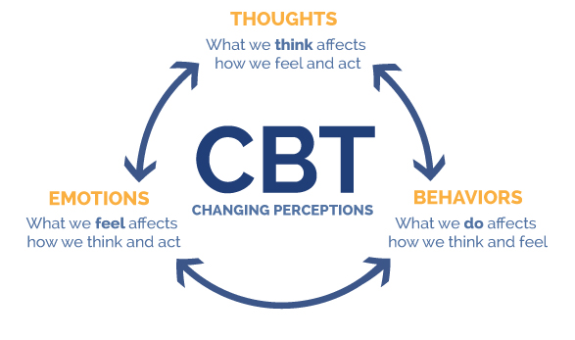

#### 

#### 

#### 

#### 

#### 

#### 

#### 

#### 

#### **SELF CARE:** Self-care is any activity that we do deliberately in order to take care of our mental, emotional, and physical health. Although it’s a simple concept in theory, it’s something we very often overlook. Good self-care is key to improved mood and reduced distresses. It’s also key to a good relationship with oneself and others.

<https://www.ted.com/playlists/299/the_importance_of_self_care>

#### **Self-awareness:** is about being honest with yourself (Keep a daily private journal, Pay attention to your self-talk, Create some space for yourself, Put a name to your feelings and emotions)

WHY SELF CARE? PHILOSOPHICAL BACKGROUND

[Michel Foucault](https://en.wikipedia.org/wiki/Michel_Foucault) understood the art of living (French *art de vivre*, Latin *ars vivendi*) and the care of self (French *le souci de soi*) to be central to philosophy. For Foucault, the notion of *care of self* (*epimeleia heautou*) of [Ancient Greek and Roman philosophy](https://en.wikipedia.org/wiki/Ancient_Greek_philosophy) comprises an attitude towards the self, others and the world, as well as a certain form of attention. For Foucault, the pursuit of the care for one's own well-being also comprises [self-knowledge](https://en.wikipedia.org/wiki/Philosophy_of_self#Self-knowledge) ([gnōthi seauton](https://en.wikipedia.org/wiki/Know_thyself)).

Around the same time that Foucault developed his notion of care of the self, the notion of self-care as a revolutionary act in the context of social trauma was developed as a social justice practice in [Black feminist thought](https://en.wikipedia.org/w/index.php?title=Black_feminist_thought&action=edit&redlink=1) in the US. Notably, civil rights activist and poet [Audre Lorde](https://en.wikipedia.org/wiki/Audre_Lorde) wrote that in the context of multiple oppressions as a black woman, “caring for myself is not self-indulgence, it is self-preservation, and that is an act of political warfare.”

(En resumen: en un mundo de capitalismo salvaje donde somos máquinas de productividad, cuidarnos a nosotros mismos es un acto de rebelión)

**ANXIETY - Insomnia, worries, obsessive thoughts**

**Exercises**

-Body Scan

-Progressive Muscle Relaxation

-Realistic self-talk:

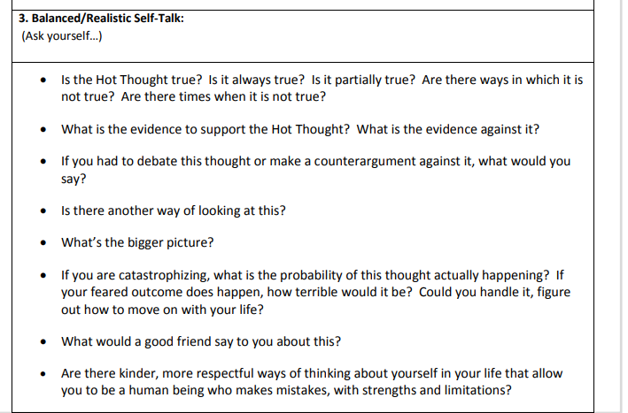

-Anxious thoughts

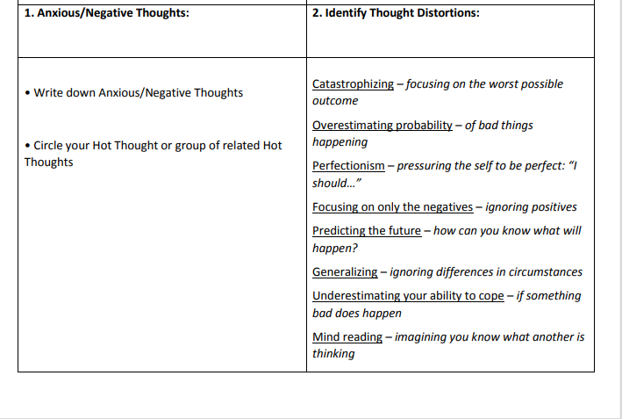

<https://www.youtube.com/watch?v=ZyJWalXcC4E>

**DEPRESSION (Apathy, lack of energy, sadness, crying outbursts, suicide thoughts)**

**Exercises:**

How can I ensure I laugh? Examples: Watching a funny video, telling a joke to a friend, reminiscing about good times, being around people who make you laugh.

How can I let myself worry – in a healthy way? Examples: Planning ‘Worry Time’ every day, watching a sad movie, taking time to remember people who are no longer with you, journaling.

How can I exercise my brain? Examples: Doing puzzles, trying a new recipe, learning a new language outside of the classroom, having debates with friends.

How can I relax my thinking? Examples: Watching TV, doing meditation, letting your mind wander, trying to do absolutely nothing for at least five minutes.

https://www.youtube.com/watch?v=-kfUE41-JFw

<https://www.youtube.com/watch?v=UoLWYhwROBI>

**SOCIAL ANXIETY (Social phobia, intimacy phobia, public places avoidance)**

People with social anxiety tend to fear and avoid social situations. They are very concerned that they will do something embarrassing, or that others will judge them. It is normal to feel anxious in social situations from time to time. For example, most people feel anxious when they have to speak in front of a large group. Social anxiety becomes a problem when it becomes quite distressing and starts getting in the way of your ability to function and enjoy life. However, it is important to note that you are not alone. Social anxiety is one of the most common anxiety disorders. The good news is that there are strategies you can use to help manage your social fears.

**Exercises:**

How can I connect with other people?

Examples: Going to a party, texting friends, re-connecting with high school friends, going for coffee with a classmate, reaching out for support when something is bothering you.

How can I disconnect when social interactions are getting too much? Examples: Turning off your phone for an hour, going for a walk, going for coffee with yourself.

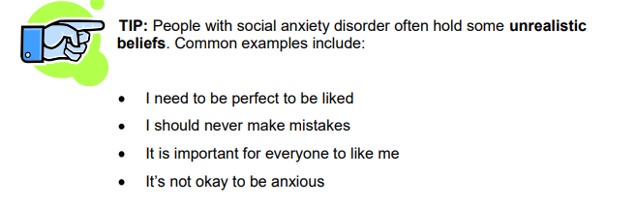

**STRESS (unregular sleeping and eating patterns, concentration problems, related health problems, constant activity/lack of time for oneself)**

**Exercises:**

How can I be physically active? Examples: Going to the gym, taking a walk, doing yoga, hiking, biking.

How can I relax? Examples: Taking a bath, having a nap, doing meditation, laying on the beach, going to bed early. 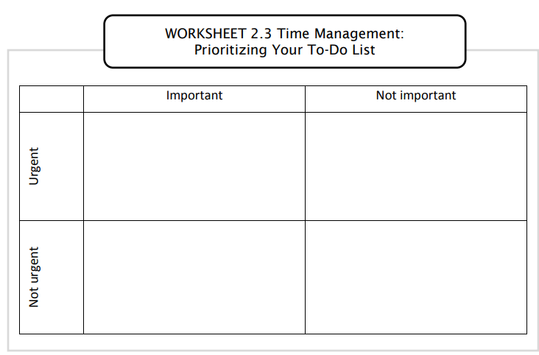

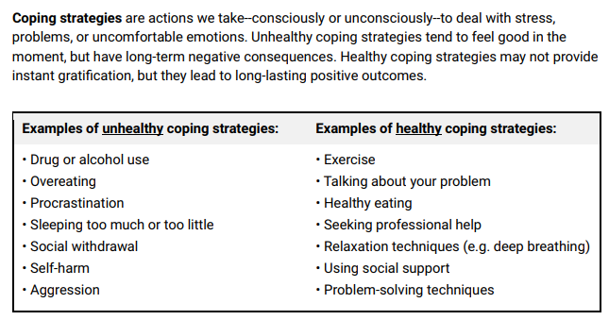

<https://www.youtube.com/watch?v=bI9eAbr3Bjo>

**Relieve stress / anxiety exercises** *(2-5 minutes long)*

**1. Mindful Hand Awareness Exercise**. Grasp your hands tightly for five seconds, then release and notice how your hands feel. Keep your attention focused on the feeling for as long as you can. This is a wonderful exercise for getting out of your head and into your physical awareness.

**2. Music Appreciation**. Yes, singing along to your favorite song counts as a mindfulness exercise! Pay attention to how this piece makes you feel. What emotions do you experience? What memories come up, and how do those memories make you feel? Savor these emotions and see if they carry over throughout the day.

**3. Close Your Eyes.** Spend 5 minutes in silence while you appreciate your surroundings. Keeping your eyes closed helps to block out stimulation and sharpens your non-visual awareness.

**4. Game of Fours**. Notice four things in your day that generally go unnoticed. For example, fire up your senses and appreciate the sound of children giggling while riding their bikes, the fresh scent of soap in your shower, your coworker’s hearty laugh, or the brightest flowers in your garden.

**5. Eye contact / smile**. Intentionally making eye contact and smiling at someone you don’t know on the street, in the subway, etc can unintentionally make their day. Civility and kindness never go out of fashion.

**Mental care through physical exercise!**

Exercise certainly isn’t a depression cure-all, but a study published in the *Journal of Sport and Exercise Psycholog*y found that heart-pumping, endorphin-boosting workouts actually

promote happiness. Researchers say that more physically active people reported greater general feelings of excitement and enthusiasm than less-active people. And beyond its protective effect against feelings of depression, exercise may reduce stress and help you secure a better night’s sleep.“Endorphins are our body’s natural morphine and, when released by special glands in our brains, they can produce a sense of well-being or joy and also decrease pain levels.”

*Tips to get started with your physical exercise*

· 5 X 30: Jog, walk, bike, or dance three to five times a week for 30 minutes.

· Set small daily goals and aim for daily consistency rather than perfect workouts. It's better to walk every day for 15-20 minutes than to wait until the weekend for a three-hour fitness marathon. Lots of scientific data suggests that frequency is most important.

· Find forms of exercise that are fun or enjoyable. Extroverted people often like classes and group activities. People who are more introverted often prefer solo pursuits. It doesn’y matter.

· Distract yourself with an iPod or other portable media player to download audiobooks, podcasts, or music. Many people find it’s more fun to exercise while listening to something they enjoy.

· Recruit an “exercise buddy.” It's often easier to stick to your exercise routine when you have to stay committed to a friend, partner, or colleague.

1. **Running**

When it comes to workouts that fight depression, aerobic and cardio exercises have the edge. “To date, the strongest evidence seems to support aerobic exercise,” says Dr. Muzina. While the correct "dose" of depression-fighting exercise is up for debate, some experts recommend 20 to 30 minutes most days of the week. A recent review of numerous scientific studies found no association between the intensity level of the exercise and its emotional benefit — so simply moving more is a great start. Ever heard of runner’s high? “The most tangible example of exercise stimulating certain brain chemicals is the runner’s high that many athletes report experiencing once crossing a certain threshold of exertion while running,” explains Muzina. That euphoria is due to the release of endorphins in the brain in response to the sustained physical activity.

**2. Or just get your walk on**

Simply putting one foot in front of the other may be the trick to feeling better — that’s because walking is an aerobic exercise that’s suited for almost everyone. All it takes is a pair of comfortable, supportive shoes, and you’re ready to go.

“Practical wisdom suggests that doing something is better than doing nothing in terms of physical activity,” says Muzina. If depression has made you sedentary, start off slowly and gradually increase time and distance**.**

**3. Go play outside**

If you enjoy being outdoors, even simple activities such as gardening, throwing a ball around with your kids, or washing your car may do you some good. That’s because a healthy dose of sunlight has been shown to boost mood, likely due to the fact that sunshine stimulates our serotonin levels (drops in serotonin during the darker, colder months have been linked to seasonal affective disorder, or SAD). “Just moving your body inside or out is exercise,” says Shoshana Bennett, PhD, a clinical psychologist and author of Postpartum Depression for Dummies. “Choose whatever works for you, depending on your functioning level, energy, and preferences.”

**4. Have you ever tried yoga?**

Ohm — in a study of 65 women with depression and anxiety, the 34 women who took a yoga class twice a week for two months showed a significant decrease in depression and anxiety symptoms, compared to the 31 women who were not in the class.“Eastern traditions such as yoga have a wonderful antidepressant effect in that they improve flexibility; involve mindfulness, which breaks up repetitive negative thoughts; increase strength; make you aware of your breathing; improve balance; and contain a meditative component,” says Norman E. Rosenthal, MD, a clinical professor of psychiatry at the Georgetown University School of Medicine in Washington, D.C. Dr. Rosenthal suggests starting with a yoga class in your area so you can be sure that you’re doing the movements and poses properly.

**Long commitment routines and exercises**

**1. Create a soothing space**

Research suggests that warm colors like red excite you and cooler, muted colors like blue, green, or grey relax you, says Molly Roberts, MD, president of the American Holistic Medical Association—but surrounding yourself in any color you find soothing can help bring on calm. "The theory behind the use of color therapy is that colors enter the eyes, which then send messages along the nerve pathways to the area of the brain that regulates emotion," Roberts says. "There are a lot of ways to surround yourself with colors that can ease stress throughout the day." Her suggestions: at home, paint an accent wall; and at the office, drape a soothing-colored scarf over the back of your chair and change your computer screensaver.

**2. Pick up a physical hobby**

If scrapbooking isn't your thing, try to find another activity to occupy your time. "What stress does to someone's mind is flood it with thoughts," explains Dr. Nadkami. "All of these thoughts knock about your head and they make you feel overwhelmed." Sound familiar? The best way to stop the stress spiral is by refocusing your mind on one thought: Gardening focuses you on the physical feeling of the soil that you can hold in your hands. Knitting concentrates your thoughts on the predictability of loops of yarn. "The important thing is that you channel your energy into one thing and this, in turn, relaxes your mind by eliminating all of the distracting stresses," says Dr. Nadkarni.

**3. Clench your muscles (then release) / tensar y contraer**

This technique was developed in the 1930's and has been recommended ever since. "The idea behind progressive muscle relaxation is to first create muscle tension, then relaxation, to provide physical relief. A relaxed body often leads to a relaxed mind," says Savelle-Rocklin. Start by getting into a comfortable position, like lying down in loose clothing. Tense and relax each muscle group for five seconds at a time, starting with your forehead, then moving down to your eyes, lips, hands, forearms, shoulders, back, stomach, hips, thighs, feet and, finally, your toes. If any muscle remains tense after the sequence, tighten and relax it three or four times.

**4. Take a Mental Mini-Vacation**

As your workday (or your day as a student, parent, or homemaker) comes to a close, your body and mind have accumulated a lot of stress. You may feel exhausted and mentally drained. It’s not uncommon to carry that agitation home with you if you don’t create a peaceful transition from the demands of your day to the start of your evening.

Create a mindful transition from your workday to your home life using a simple visualization practice—a mental vacation. By visualizing your perfect relaxation spot, you can put yourself in a calm, restful, and happy state of mind that allows you to move on peacefully to your next responsibilities.

**5. Practice Walking Meditation**

A walking meditation requires engaging all your senses. You are intentionally aware of your feet hitting the ground, your eyes taking in the sights around you, your lungs breathing the air in and out, and your ears hearing every sound. It’s a practice that allows you to be more connected with the environment, which is an essential part of who we are. Being in nature releases you from the ongoing internal dialogue of your mind and makes you more aware of the beauty of the outdoors. By combining walking with mindfulness, you are practicing an excellent habit for releasing the stress of the day so you can transition to your evening activities in a more harmonious frame of mind.

**6. Evening Gratitude Journaling**

By the time you’re ready for bed, it has been a long day. Even if you’ve been consciously mindful over the past sixteen hours, you probably have accumulated some stress or even have experienced a few unresolved issues. If you keep a gratitude journal that you write in before bedtime, you can do wonders for improving your sleep. For instance, one study found this habit decreased depression, and another one discovered that showing evening gratitude increased optimism, sleep quality, and overall health and lowered blood pressure. So if you want to have an easier night’s sleep, with better sleep quality, please consider an evening gratitude journaling session.

**7. Create a Dinner Ritual**

Creating a ritual around the evening meal is an ideal mindfulness habit to establish with your family/ friends. It blends all of these benefits into an occasion that is celebrated nightly but can yield a lifetime of memories and closeness for you and your people.

A dinner ritual reconnects your family/friends each evening in a powerful way, helping each member focus on celebrating good company. It offers a sacred respite from the pressures of work, school, and life in general, especially if you reinforce that the dinner table is an inviolable space where negativity and distractions are not allowed.

**8. Cultivate Humility**

When you are humble, you are grounded in yourself with enough self-assurance and poise that you don’t need to show off, act defensive, or toot your own horn.

When you practice humility, you intentionally let go of self-aggrandizing behaviors and thoughts that put you in a “me first” frame of mind. Working toward humility is a growth experience in which you no longer need to see yourself above others—nor do you put yourself below them. You have a sense of confident neutrality about who you are as compared to others. You view your own strengths and weaknesses accurately, and you recognize that everyone has intrinsic value, even those who appear “beneath” you in some way.

**9. Create a Tea or Coffee Ritual**

Rather than stumbling to the coffee maker or teapot in a sleepy haze and slugging down that first cup, you can create a morning ritual around this daily habit. This ritual doesn’t have to be limited to tea. You can also make a ritual of your morning coffee, as it can involve similar steps in preparation. But you don’t need to follow any ancient traditional ceremony to enjoy your own morning ritual. All you really need to do is slow down, pay attention, and savor.